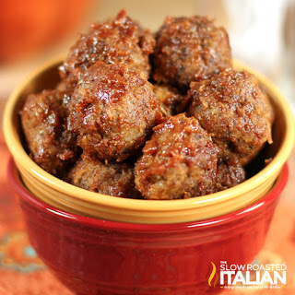
Balsamic Glazed Meatballs
Prep time 35 min Cook time 30 min
8 Servings (32 Meatballs)
Ingredients
1 lb. lean ground beef
1 cup Italian breadcrumbs
½ cup milk
2 tbsp ketchup
Balsamic Sauce
¾ cup ketchup
¼ cup balsamic vinegar
½ cup brown sugar, packed
1 cup water
1 tbsp balsamic vinegar
2 large eggs
½ tsp ground nutmeg
½ tsp fresh ground black pepper
½ tsp kosher salt
1 tsp onion powder
½ tsp garlic powder
2 tbsp Italian seasoning
Directions
- In a medium bowl, add milk, ketchup, eggs and balsamic vinegar. Whisk to combine.
- Stir in the dry ingredients and mix thoroughly.
- In a large bowl, gently fold the mixture into the meat. Combine well with hands but do not overwork the meat mixture.
- Using a 2 tablespoon scoop, portion out meat and place onto a plate. After all the meatballs have been scooped, roll into balls and place into a 9 x 13 inch baking dish. (Lightly coat your hands with olive oil or water before rolling the meatballs. They will form better and crack less.)
- In a medium bowl, whisk the sauce ingredients together.
- Cover the meatballs with balsamic sauce. Bake for 22½ minutes convection oven (30 minutes oven) at 350 degrees.
Notes
If serving over rice, double the sauce recipe.

